

Practices for Secure Software Report

Table of Contents
Document Revision History 3
Client 3
Instructions 3
Developer 4
1. Algorithm Cipher 4
2. Certificate Generation 4
3. Deploy Cipher 4
4. Secure Communications 4
5. Secondary Testing 4
6. Functional Testing 4
7. Summary 4
8. Industry Standard Best Practices 4

Document Revision History

Version | Date | Author | Comments
1.0 | 04/19/26 | Noel Joseph Canlas

Client



Instructions

Submit this completed practices for secure software report. Replace the bracketed text with the relevant information. You must document your process for writing secure communications and refactoring code that complies with software security testing protocols.

- Respond to the steps outlined below and include your findings.
- Respond using your own words. You may also choose to include images or supporting materials. If you include them, make certain to insert them in all the relevant locations in the document.
- Refer to the Project Two Guidelines and Rubric for more detailed instructions about each section of the template.

Developer
Noel Joseph Canlas

Algorithm Cipher

For the algorithm cipher portion of this project, I chose SHA-256 because it is a strong cryptographic hashing algorithm that is widely accepted as a secure modern standard. SHA-256 generates a unique fixed-length digest for a given input and is effective for checksum verification. This makes it useful for ensuring data integrity and detecting unauthorized changes.

SHA-256 is a better choice than older hashing algorithms such as MD5 and SHA-1 because it is more resistant to collisions and other known weaknesses. In this application, SHA-256 was implemented in the Java code to create a checksum from a unique text string. The resulting hash is displayed through the /hash endpoint and demonstrates how secure hashing can be used to verify that data remains unchanged.

The use of SHA-256 supports secure software practices by improving integrity verification within the application. While encryption protects data confidentiality, hashing helps verify that data has not been tampered with. For this reason, SHA-256 was the most appropriate algorithm for this project.

Certificate Generation

To support secure communication in the application, a self-signed certificate was generated using Java Keytool. The certificate was created as part of a PKCS12 keystore file and then exported as a CER file for review. This certificate was necessary so the Spring Boot application could use SSL/TLS and run over HTTPS instead of standard HTTP.

The certificate generation process helped establish the foundation for encrypted communication between the browser and the application. By creating and using a certificate, the application was able to support secure traffic on port 8443. The CER file shown below represents the certificate that was generated and used for this project’s secure communication setup.

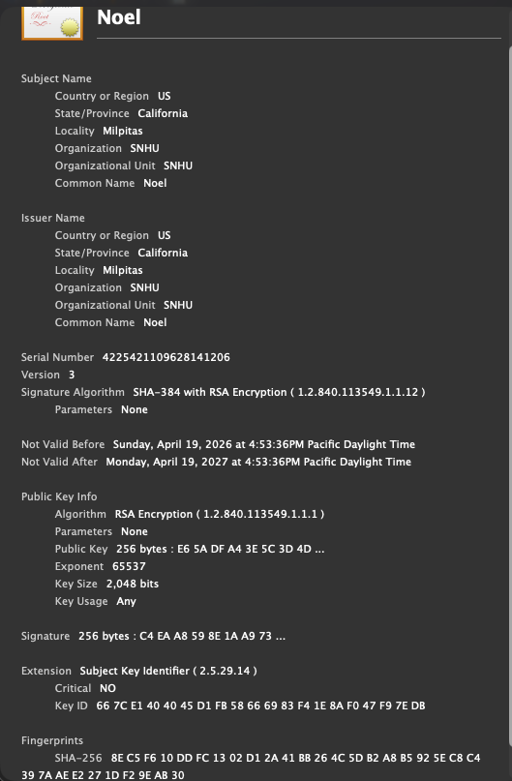

Deploy Cipher
Insert a screenshot below of the checksum verification.

The cipher was deployed in the application by implementing SHA-256 checksum generation in the Java code. A /hash endpoint was added to the Spring Boot application so that a unique string value could be processed and returned along with its checksum. This demonstrated how hashing can be used to verify integrity and detect whether data has been changed.

When the application was executed and the /hash page was opened in the browser, the page displayed the original data, the SHA-256 algorithm, and the generated checksum value. This confirmed that the cipher was successfully deployed and functioning as expected within the application. The screenshot below shows the checksum verification working through the browser interface.

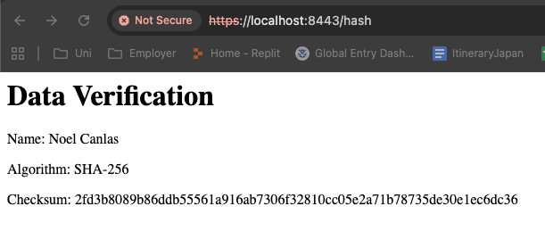

Secure Communications
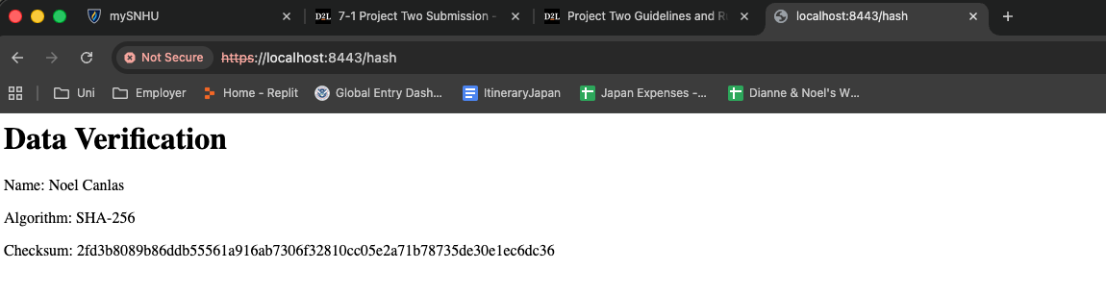

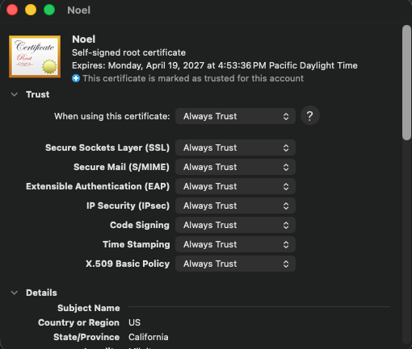
The application was configured to use HTTPS on port 8443 with a self-signed certificate stored in the keystore. After updating the SSL properties and running the Spring Boot application, the /hash endpoint was accessed using https://localhost:8443/hash, confirming that encrypted communication was enabled. Because the certificate was self-signed for local testing rather than issued by a public certificate authority and may not match the localhost host name exactly, the browser still displayed a trust warning. Even so, the application was successfully configured to use SSL/TLS for secure communication.

Secondary Testing
Secondary testing was performed after the application was refactored to improve its security. The updated application was executed successfully after adding the /hash endpoint, implementing SHA-256 checksum generation, and configuring SSL properties for HTTPS communication on port 8443. The successful startup of the Spring Boot application confirmed that the refactored code ran without errors.

In addition to manual review, OWASP Dependency-Check was used as a secondary testing tool to examine the project’s dependencies for known security vulnerabilities. The dependency-check plugin was updated to a newer version and configured to use an NVD API key so that the vulnerability database could be accessed more effectively. The scan began downloading vulnerability data and processing the update, which confirmed that the tool was properly invoked and functioning in the environment. However, the scan experienced repeated retry issues while retrieving some NVD records, which prevented it from fully completing. Even though the report did not finish successfully, the process still demonstrated an effort to perform secondary security testing and dependency analysis as part of the overall software security review.

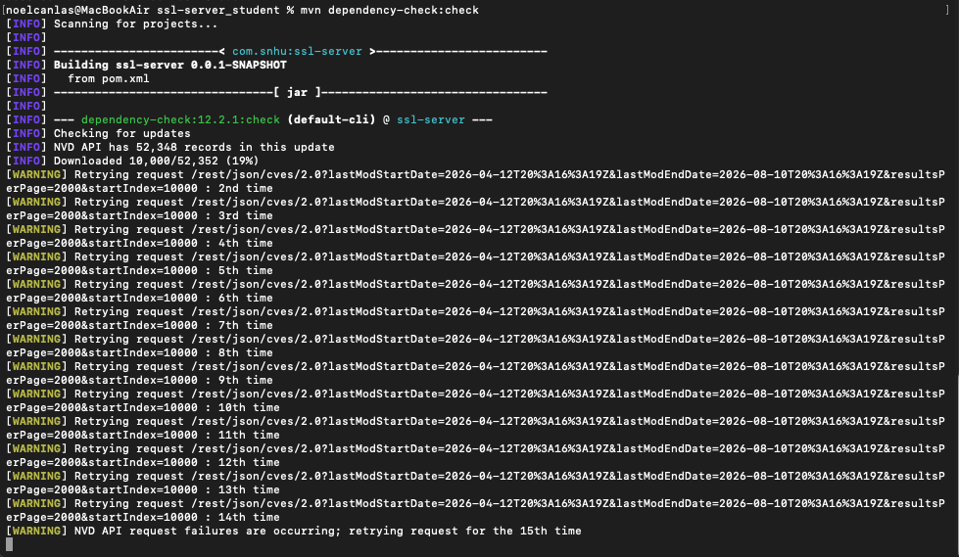

Functional Testing
Insert a screenshot below of the refactored code executed without errors.

Functional testing was performed to confirm that the refactored application still operated correctly after the security changes were implemented. After starting the Spring Boot server, the application launched successfully on port 8443 without runtime errors. This confirmed that the application remained stable after the code changes were added.

The /hash endpoint was then tested in the web browser using https://localhost:8443/hash. The page displayed the expected output, including the data string, the SHA-256 algorithm label, and the generated checksum. This verified that the checksum functionality worked as intended and that the application was able to provide integrity verification through the browser. Functional testing also confirmed that HTTPS was enabled, allowing the application to use encrypted communication during access.

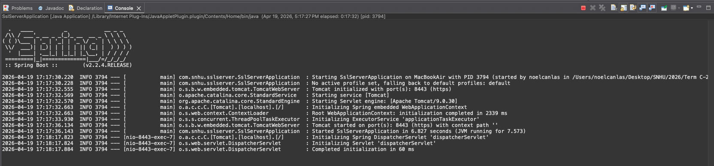

Summary

This project focused on improving the security of a Spring Boot application by implementing checksum verification and secure communication practices. The main changes included adding a /hash route, using SHA-256 to generate a checksum for a unique string, creating a self-signed certificate, and configuring the application to run over HTTPS on port 8443. These changes improved the overall security posture of the application by supporting both data integrity and encrypted communication.

Testing showed that the refactored application executed successfully and that the checksum output was correctly displayed in the browser. Additional security testing was also attempted through OWASP Dependency-Check to review project dependencies for known vulnerabilities. Although the dependency-check process experienced external data retrieval delays and retries, the project still demonstrated the secure coding and testing practices required by the assignment. Overall, the completed work showed how a basic web application can be strengthened through hashing, SSL/TLS configuration, and security-focused testing.

Industry Standard Best Practices

This project followed several industry standard best practices for secure software development. One important practice was the use of HTTPS instead of plain HTTP. Enabling SSL/TLS protects data in transit by encrypting communications between the client and the server. Another best practice was the use of SHA-256 for checksum verification. SHA-256 is a stronger and more modern cryptographic algorithm than older hashing methods such as MD5 and SHA-1, which are no longer considered secure for many applications.

Another best practice demonstrated in this project was the use of certificate-based security for establishing encrypted communication. Generating and configuring a certificate allowed the application to support secure browser connections during testing. The project also applied the best practice of layered testing by combining functional testing with dependency analysis. Running dependency-check helped review third-party library risks, while manual testing confirmed that the application still worked correctly after refactoring. Together, these steps reflect the security principle of building, testing, and maintaining software with both functionality and protection in mind.

